**Potential denitrification rate assay**

by C Thorn; last updated August 2017; FEM lab, NUIG (Dr Abram)

Aim of the assay: To determine the *capacity* of microbial communities within soil/sediment to perform denitrification *when conditions are optimal*

What is being measured: The rate of conversion of nitrates to N2O (when N2O -> N2 is blocked by acetylene gas) per gram dry weight (dw) of soil. The method is based on that of Smith and Tiedje (1979).

Resources/references used for this protocol are listed at the end of document

Soil used for this assay should be either direct from experimental microcosms, or if sampled from the field, the assay should be performed on the day of soil collection. Ideally you should know the pH of your soil prior to assay as this will affect the pH of the buffer used.

# Equipment needed

* Flasks (approx. 120 - 150 ml volume) for incubation, with airtight rubber stoppers (from Fisher: Fisherbrand turnover septum stoppers) – see image on page 2.
* Pre-evacuated gas sampling vials (7 ml volume)
* Airtight syringes; needles (fine gauge to prevent holes in stoppers); luer lock valves (see image on page 3).
* Oxygen free gas (e.g. He or N2)
* Acetylene gas
* GC for measuring nitrous oxide

# Stock solutions

* 0.2 M KH2PO4 stock solution (aka monobasic): 2.722 g KH2PO4 in 100 mL H2O.
* 0.2 M K2HPO4 stock solution (aka dibasic): 3.843 g K2HPO4 in 100 mL H2O.
* 1M KNO3
* 0.1M glucose
* 0.1M succinate (Morley *et al.,* 2014)
* if keeping for more than 1 week consider autoclaving/filter sterilising as appropriate for reagent.

# Denitrifying buffer solution:

Dibasic and monobasic phosphate will be mixed in a particular ratio to give buffer of the same pH as soil being tested (see table 1 in supplementary info):

* Prepare working solution of phosphate buffer to give 2 mM potassium buffer at appropriate pH. For example pH 6 would be 13.2% dibasic and 86.8% monobasic:
  + 1.32 ml of 0.2M dibasic PO4
  + 8.68 ml of 0.2 M monobasic PO4
  + add 990 ml of dH2O to give 1L of 2mM PO4 buffer (only good for 1 day)
* Working concentration of KNO3 & sugars in complete buffer will be 10mM each:

For example to make 200ml of complete buffer (enough for 10 samples),

* + add 2ml of stock KNO3
  + add 10 ml of glucose stock
  + add 10 ml of succinate stock (combined this gives 10mM carbon source concentration)
  + top up to 200 ml with the fresh 2mM PO4 buffer at pH 6.

• Complete buffer solution is best if used right away (or next day).

# Method

1. Label and pre-weigh 150 ml flasks (record weights for calculating dw of soil at end of assay)
2. Weigh 20g (fresh weight) soil into each flask
3. Add 20ml of buffer solution
4. Seal flasks with rubber stopper, insert two needles, one for inserting gas and one for venting gas back out. Insert gas line to one needle and flush flasks with oxygen-free gas (He or N2) for approx. 2 mins per flask to flush out all O2. Then quickly remove both needles at once in a smooth motion
5. Allow excess pressure to escape from vials by inserting needle with an attached, empty 50ml syringe (type with rubber seal) = flasks are at atmospheric pressure.
6. Then add 15 ml of acetylene gas (or enough to be 10 % of headspace).
7. Incubate flasks on a shaker (90 rpm) at 15° C
8. At regular time intervals (30, 60 and 90 minutes) take a gas sample. These will be placed into pre-evacuated gas sampling vials. Using an airtight syringe with valve above needle (pictured below) remove 12 mL of headspace (for 7ml vial). Close tap when transferring gas sample from flask to gas vial. (see **note 1 and 2** below).
9. Push 12 ml into 7 ml gas sample vial = over pressurised vial which is better for storage and means if there is a little leak in the vial, air will go out and not in.
10. Shake flasks between sampling periods & repeat gas sampling.
11. Once the assay is finished, remove rubber stoppers and place flasks in drying oven at 110° C overnight. Weigh flasks again and use this (minus flask weight) to calculate % soil dry weight (dw).
12. Determine N2O concentration of the samples and standard gas samples by gas chromatography.

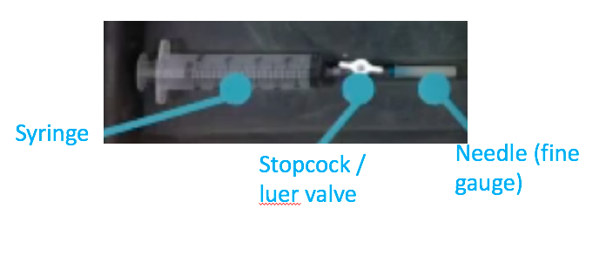

**Note 1:** To see an example of taking a gas sample and placing in a gas sample vial using the syringe set up described, see the following video protocol (Collier et al., 2014) at roughly 6 minutes.

[**https://www.jove.com/video/52110/measurement-greenhouse-gas-flux-from-agricultural-soils-using-static**](https://www.jove.com/video/52110/measurement-greenhouse-gas-flux-from-agricultural-soils-using-static)

(in this video, the vials are not pre-evacuated so sample transfer is a little different).

**Note 2**: At each sample point you will be removing headspace gas and thus the pressure will get more negative so the tap is important to stop the syringe sucking atmospheric air into the syringe when transferring to the gas sampling vial. Some protocols replace the 12 ml of headspace sample taken at each point with 12 ml of N2 (I didn’t do this, and altered my headspace volume accordingly in the calculations).

# Data analysis and Calculations

N2O data need to be converted from parts per million (ppm) to µl N2O L-1 headspace using the ideal gas law as in the following formula:

$$C_{m}=\frac{C_{v}×M×P}{R×T}$$

Where:

Cm = mass per volume concentration (µl N2O / L) and

Cv = volume per volume concentration ppm.

M = molecular weight of trace gas (i.e., 28 to µg N2O -N/ µmol N2O);

P = barometric pressure in atmospheres;

T = air temperature in ° K and

R = the universal gas constant (i.e., 0.0820575 L atm•°K•mole).

The rate of denitrification (DR) are then calculated using the following formula as described in Groffman *et al.* (1999), as detailed below:

$$DR=\frac{(C_{90}×H)-\left(C_{30}×H\right)}{\left(D×T\right)}$$

Where:

C30 = µg N2O -N/ L headspace after 30 minutes of incubation

C90 = µg N2O -N/ L headspace after 90 minutes of incubation;

H =the flask headspace (L);

D = the dry weight of soil used in the assay;

T = the duration between the two timepoints analysed, expressed in hours.

You can calculate this rate again between your other time points and check for anomalies – the rates aquired from comparing different timepoints should be similar. There are a variety of methods/calculations for DNR. Another method is to plot a line and check the R2 value to check for anomalies/errors in your data. To try this alternative calculation method, see supplementary info.

Rates are then expressed as the mean of (at least) three biological replicates

# Resources used

Collier et al., 2014 Measurement of Greenhouse Gas Flux from Agricultural Soils Using Static Chambers. JoVe. URL: https://www.jove.com/video/52110/measurement-greenhouse-gas-flux-from-agricultural-soils-using-static

Groffman, P., Holland, E., Myrold, D., Robertson, G. & Zou, X., 1999. Denitrification. In G. P. Robertson, C. S. Bledsoe, D. C. Coleman, & Sollins P., eds. *Standard Soil Methods for Long-Term Ecological Research*. Oxford University Press, pp. 273–288.

Morley, N.J., Richardson, D.J., Baggs, E.M., Lindow, S. & Senoo, K., 2014. Substrate Induced Denitrification over or under Estimates Shifts in Soil N2/N2O Ratios V. Shah, ed. *PLoS One*, 9(9), p.e108144.

Smith, M.S. & Tiedje, J.M., 1979. Phases of denitrification following oxygen depletion in soil. *Soil Biology and Biochemistry*.

# Supplementary information

1. **Table 1: Creating phosphate buffer of a certain pH by mixing different ratios of dibasic to monobasic phosphate:**

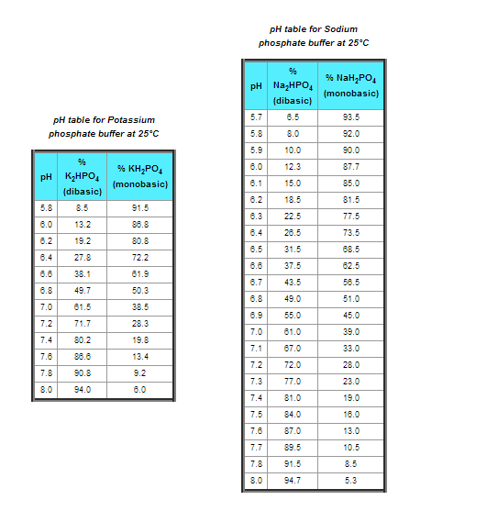

1. **Alternative method for calculating denitrification rate (here referred to as DEA – denitrifying enzyme activity)**

**N2O Determination**

• Determine N2O concentration of the samples and standard gas samples by gas chromatography.

• The concentration of N2O in the vial is calculated by using peak area obtained in a calibration curve determined by plotting the areas for known concentrations of standard gas.

• The rate of N2O accumulation in the headspace is determined by plotting the change in N2O concentration against the exact number of minutes expired from the start of the experiment to the time of each sampling.

• Sampling dilution and dissolution N2O in aqueous phase must be incorporated into the determined N2O concentration.

• The readjusted N2O concentration can be determined from the following equations:

• **N2O mg in the headspace (hs) =** (original N2O (μL·L-1)/ (82068 μL·atm·mol-1·K-1 x (273+ temperature (°C) K))x1000mmoles·mol-1 x 44mg·mmol-1 x hs (L)

• The headspace volume (hs) equals the total volume of the flask as well as 20 mL which accounts for the C2H2 addition which brought the pressure above atmospheric, minus the volume of the soil (assuming a bulk density of 1 g/cm3) and the buffer.

• To incorporate the dilution resulting from the removal of N2O during sampling and replacing each sample with He the N2O (mg) in the N2O content of the sample taken previously must be added to the cumulative N2O (mg) in the headspace of the present sample. This does not pertain to the first sample. To determine the amount of N2O (mg) to be added to in the current headspace N2O, the N2O (mg) content of the previous sample must be multiplied by the fraction of volume removed from the headspace. For example, if a 20 mL sample had been removed from the headspace and your headspace volume was 120 mL, you would multiply the mass of N2O (mg) determined for the previous sampling time by the ratio of He added to headspace volume (20/120). The resulting mass of N2O (mg) should be added to N2O (mg) in the headspace of the present sampling time before you proceed to the next step.

• **Total N2O mg (including dissolved N2O) =** N2O mg in the headspace x (1+ α (soil+buffer solution(L) / headspace (L))

α = 0.778 @ 15°C

0.676 @ 20°C

0.594 @ 25°C

• **Total** **N2O-N μg (including dissolved N2O) =** Total N2O mg (including dissolved N2O) x 28g·mol-1/ 44g·mol-1 x 1000μg·mg-1

• The rate of N2O production (DEA) is determined as a linear regression or trend line. Use the LINEST function on Excel to find the slope of DEA by setting:

y = Total N2O-N μg (including dissolved N2O)

x = corresponding time in hours.

constant = 1

stats = 0

• Determine the R2 of each slope to insure that it is a good relationship, it should be higher than 0.8. If the R2 is lower than 0.8 determine whether there is a point that can be omitted to obtain a better relationship.

• To express the rate of N2O production (DEA) per gram of soil the rate must be divided be the dry soil weight.

DEA = slope (ug N h-1) x / (sample wet weight / (1 + gravimetric water content))

• DEA is expressed as μg N g-1 soil h-1.